**Purchase Order**

|  |  |
| --- | --- |
| Seq | 30 |
| Description | Restrict PO Creation |
| **Condition** |  |
| Trigger Event | WHEN-NEW-RECORD-INSTANCE |
| Trigger Object | PO_HEADERS |
| Condition | 1=1 |
| Processing Mode | Not in Enter-query mode |
| **Actions** |  |
| Seq | 10 |
| Type | Property |
| Object Type | Block |
| Target Object | PO_HEADERS |
| Property Name | INSERT_ALLOWED |
| Value | FALSE |
|  |  |
| Seq | 20 |
| Type | Builtin |
| Builtin Type | GO_ITEM |
| Argument | PO_HEADERS.OPERATING_UNIT |

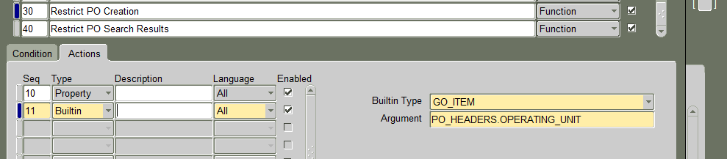

|  |  |
| --- | --- |
| Seq | 40 |
| Description | Restrict PO Search Results |
| **Condition** |  |
| Trigger Event | WHEN-NEW-RECORD-INSTANCE |
| Trigger Object | PO_HEADERS |
| Condition | 1=1 |
| Processing Mode | Not in Enter-query mode |
| **Actions** |  |
| Seq | 10 |
| Type | Property |
| Object Type | Block |
| Target Object | PO_HEADERS |
| Property Name | DEFAULT_WHERE |
| Value | Click on Get_VALUe. And add this condition to the existing value at the end  AND ATTRIBUTE_CATEGORY=’TEST’ |
|  |  |

**Purchase Order Summary**

|  |  |
| --- | --- |
| Seq | 10 |
| Description | Restrict Search Results |
| **Condition** |  |
| Trigger Event | WHEN-NEW-FORM-INSTANCE |
| Trigger Object |  |
| Condition | 1=1 |
| Processing Mode | Not in Enter-query mode |
| **Actions** |  |
| Seq | 10 |
| Type | Property |
| Object Type | Block |
| Target Object | HEADERS_FOLDER |
| Property Name | DEFAULT_WHERE |
| Value | Click on Get Value, and add the below condition to the existing value  and attribute_category='TEST' |
|  |  |
| Seq | 20 |
| Type | Property |
| Object Type | Block |
| Target Object | LINES_FOLDER |
| Property Name | DEFAULT_WHERE |
| Value | Click on Get Value, and add the below condition to the existing value  and exists (select 1 from po_headers poh where poh.po_header_id=po_header_id  and poh.attribute_category<>'TEST') |
|  |  |
| Seq | 30 |
| Type | Property |
| Object Type | Block |
| Target Object | SHIPMENTS_FOLDER |
| Property Name | DEFAULT_WHERE |
| Value | Click on Get Value, and add the below condition to the existing value  and exists (select 1 from po_headers poh where poh.po_header_id=po_header_id  and poh.attribute_category=’TEST') |
|  |  |
| Seq | 40 |
| Type | Property |
| Object Type | Block |
| Target Object | DISTRIBUTIONS_FOLDER |
| Property Name | DEFAULT_WHERE |
| Value | Click on Get Value, and add the below condition to the existing value  and exists (select 1 from po_headers poh where poh.po_header_id=po_header_id  and poh.attribute_category='TEST') |
|  |  |

**Requisitions Summary**

|  |  |
| --- | --- |
| Seq | 10 |
| Description | Restrict Search Results |
| **Condition** |  |
| Trigger Event | WHEN-NEW-FORM-INSTANCE |
| Trigger Object |  |
| Condition | 1=1 |
| Processing Mode | Not in Enter-query mode |
| **Actions** |  |
| Seq | 10 |
| Type | Property |
| Object Type | Block |
| Target Object | REQ_HEADERS_FOLDER |
| Property Name | DEFAULT_WHERE |
| Value | Click on Get Value, and add the below condition to the existing value  and attribute_category='TEST' |
|  |  |
| Seq | 20 |
| Type | Property |
| Object Type | Block |
| Target Object | REQ_LINES_FOLDER |
| Property Name | DEFAULT_WHERE |
| Value | Click on Get Value, and add the below condition to the existing value  AND exists (select 1 from po_requistion_headers prh where prh.requisition_header_id=requisition_header_id and  prh.attribute_category='TEST') |
|  |  |
| Seq | 30 |
| Type | Property |
| Object Type | Block |
| Target Object | REQ_DIST_FOLDER |
| Property Name | DEFAULT_WHERE |
| Value | Click on Get Value, and add the below condition to the existing value  AND exists (select 1 from po_requistion_headers prh where prh.requisition_header_id=requisition_header_id and  prh.attribute_category<>'TEST') |
|  |  |

**Requisitions**

|  |  |
| --- | --- |
| Seq | 30 |
| Description | Restrict Requisiton Creation |
| **Condition** |  |
| Trigger Event | WHEN-NEW-RECORD-INSTANCE |
| Trigger Object | PO_REQ_HDR |
| Condition | 1=1 |
| Processing Mode | Not in Enter-query mode |
| **Actions** |  |
| Seq | 10 |
| Type | Property |
| Object Type | Block |
| Target Object | PO_REQ_HDR |
| Property Name | INSERT_ALLOWED |
| Value | FALSE |
|  |  |
| Seq | 20 |
| Type | Builtin |
| Builtin Type | GO_ITEM |
| Argument | PO_REQ_HDR.OPERATING_UNIT |

|  |  |
| --- | --- |
| Seq | 40 |
| Description | Restrict Requisition Search Results |
| **Condition** |  |
| Trigger Event | WHEN-NEW-RECORD-INSTANCE |
| Trigger Object | PO_REQ_HDR |
| Condition | 1=1 |
| Processing Mode | Not in Enter-query mode |
| **Actions** |  |
| Seq | 10 |
| Type | Property |
| Object Type | Block |
| Target Object | PO_REQ_HDR |
| Property Name | DEFAULT_WHERE |
| Value | Click on Get_Value. And add this condition to the existing value at the end  AND ATTRIBUTE_CATEGORY=’TEST’ |
|  |  |